STRATEGIC EVALUATION OF A SINGLE BUSINESS OPPORTUNITY

NOTE: THIS IS USEFUL FOR WHAT ARE CALLED BUSINESS STRATEGY DECISIONS- HOW TO COMPETE IN A SIGLE LNE OF BUSINESS. IT IS NOT SEFULF OR CORPROATE STARTEGY, WHICH IS THE FOCUS OF THE REST OF THE KNOWLEDGE LAYER OF STRATBOT BETA

WORKBOOK

This workbook provides a framework for structured strategic analysis. Its use does not guarantee a good business outcome, and must be complemented by the users’ own knowledge.

Module I: Strategic evaluation of a business opportunity

You are probably familiar with the idea of evaluating a new business opportunity in financial terms. For instance, you might consider the amount of investment required, the payback period, discount rates, and the hurdle rate of return. But what does it mean to evaluate a business opportunity in strategic terms?

This model will walk you through a logical process for conducting such an evaluation. The purpose of a strategic evaluation of a business opportunity is to assess whether you can establish a “competitive advantage” in the business you are proposing to enter. This simply means answering the question “can you make money despite competition?” The following analysis has as ingredients both specific knowledge of the business opportunity you are considering, and an analytical structure to process that information. We provide the latter – it is presumed you can supply the former.

The first piece of information to consider is:
- Are you an existing business which is seeking to exploit a new business opportunity for the company?
- Are you a start-up which will form a company to exploit this new business opportunity?

[A / B]

If you answered A, you should use this module in conjunction with the Modules on Synergy Analysis (Module name: SYN) and Entry Strategies (ENTSTRAT)

We use the following business opportunity to illustrate the analysis:
DimSum@URdesktop!

A friend who works in the financial district of his city comes to you for advice on a great new business idea: taking orders online and then delivering dim-sum boxed lunches to the desktops of busy executives. From his personal experience, your friend knows that there is great demand in the area for dim-sum at lunch time—the three dim-sum restaurants in the area, which are about a 10 minute walk away from the office complexes, are always crowded and often have a 10 to 15 minute wait. For the restaurants, the key capacity constraint is seating, not making up the meals.

His idea works like this: clients register their orders online (and pay for them) by 11.00 am everyday. Your friend consolidates the orders and sends them on to the restaurant. They have the food packed and ready to go by noon. Your friend plans to hire 3 temporary workers to do the actual delivery by 12.30 pm (lunch time for most offices) to the various offices, which are all located very close to each other.

Your friend has got an agreement from the largest and best of the three dim-sum restaurants to provide him the food at 10% below list price (inclusive of packing). He also intends to charge a 5% mark-up on list prices for delivery from his clients. Your friend expects about £500-£750 of orders everyday. He believes the model is scaleable because his operating costs increase at a slower rate than order volume. To get things going, your friend needs to make a £1000 pound investment in getting the website set up.

Step One: Defining a business model

The first step is to be able to describe the business opportunity you are considering in terms of a business model. A business model describes the key choices that underlie participation in a business. Simply put, a business model is the set of answers to 3 questions:
- Who are the customers?
- What are we selling them?
- How will we get what we are selling into the hands of our customers?

These sound like extremely simple questions but in fact having clear and well thought out answers to these three questions may make an enormous difference in terms of your ability to succeed or fail at exploiting this new business opportunity. Professor Costas Markides at London Business School is widely known for using this simple framework to generate substantive insights about how companies can create business model innovation (e.g. by changing the answers to one or more of the who-what-how questions). In this step of the analysis, we will help you to develop clear answers to these questions, and therefore a business model.

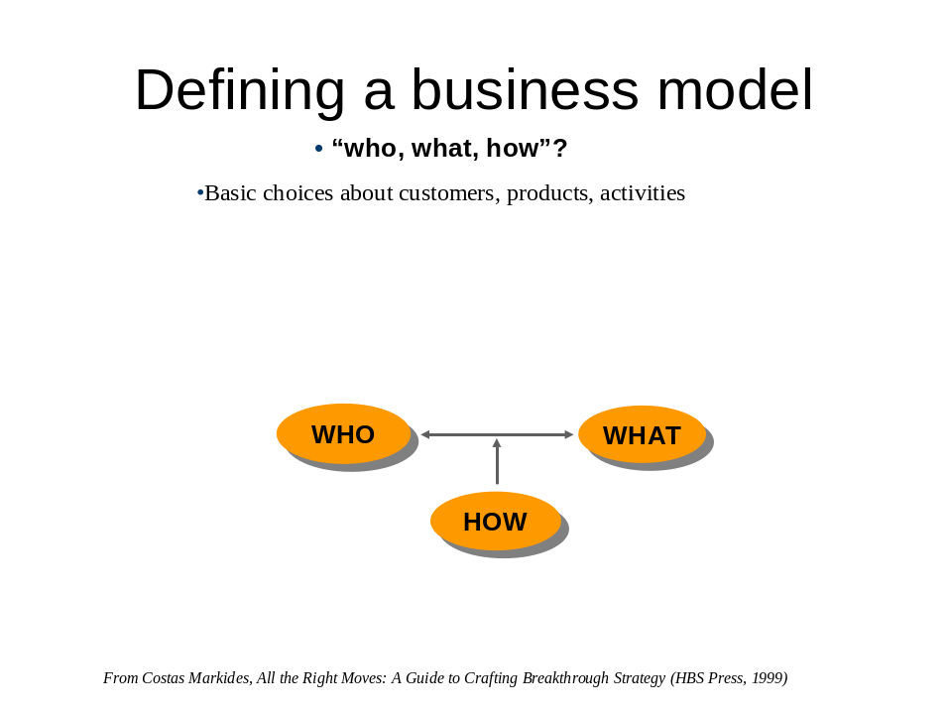

- Who: Defining the customer

Ultimately, every economically meaningful activity must have a customer. Think carefully about the business opportunity you are considering. Who will the customers be?

To help you think through this, consider the following examples.
- Microsoft's customers for its operating systems include home users and office users who work with PC compatible computers
- Apple company sells its laptops to computer users who value its distinctiveness from standard PC based architecture.
- easyJet's customers are looking for extremely cheap air fares and are willing to settle for lower levels of service and some inconvenience
- The customers of Gleneagles hotel chain are looking for a full-service, high luxury hotel experience and are willing to pay top dollar for it.

Notice that these definitions of who the customer is vary quite a bit in terms of their breadth – everybody who needs an operating system versus those who want to fly really cheap. Can you come up with a similar one sentence definition of who the customer is in the business opportunity you are considering?

Who:

Example: DimSum@URdesktop

Who: Busy business professionals who want a quick yet tasty lunch.

- What: Defining the value proposition

The next step is to develop a clear definition of what exactly you intend to sell your customers. You could define this in terms of a specific product or service, or more broadly in terms of functionality offered. To go back to the examples used above:
- Microsoft offers reliable, multi featured operating systems (with customer support), that are compatible with past versions, as well as the application software being used by customers.
- Apple company sells laptops that are distinctive in terms of design, specification, and features from mainstream PC based architecture.
- easyJet offers its customers a cheap way to travel long distances quickly and usually at lower cost than what it would take to travel by car.
- Gleneagles offers its customers the best in luxurious, personalised hotel services and associated entertainments (such as golf links and high-quality restaurants).

Can you come up with a similar one sentence definition of the products / services / value proposition at the heart of the business opportunity you are considering?

What:

Example: DimSum@URdesktop

What: Dim Sum lunches delivered conveniently to your desk

Notice that the what is being offered varies quite a bit in terms of the “features” – it can range from a plain vanilla offering (e.g. easyJet) to a full service offered (e.g. Gleneagles). In strategic analysis we use the term “differentiated offering” to indicate that your choice of “what” has many more features that distinguish it from the offerings of average players in the same business. Here is a simple visualization device developed by Professors Chan Kim and Rene Mauborgne of INSEAD to think about what features you might want to include or eliminate from your product service offering in order to make it look different from others in the same business space. It is called a value curve.

Value curves are a nice graphical representation of what your product offering may look like compared to those of your competitors. Here’s what the value curves might look like for the example case DimSum@URdesktop.

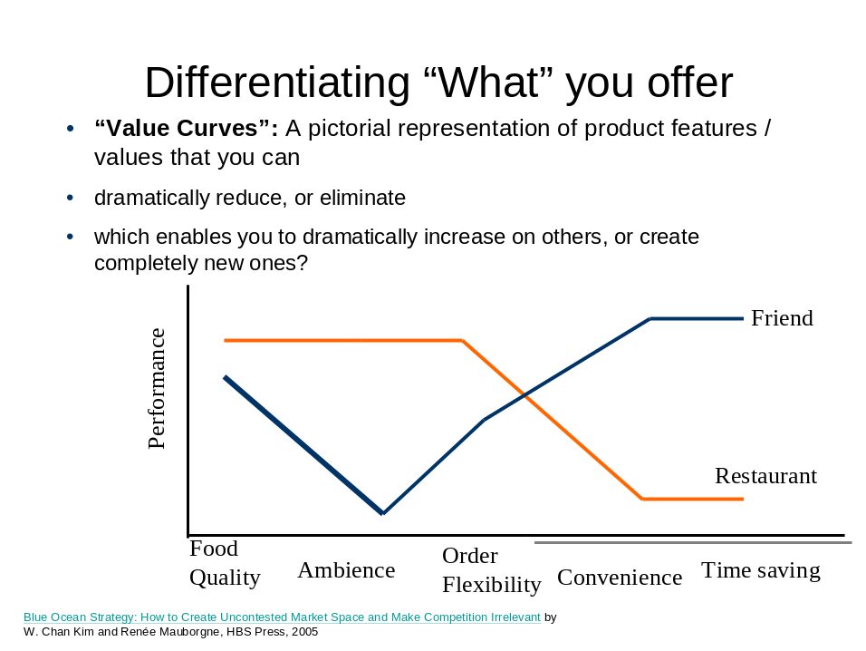

Curb the temptation to depict your offering as being superior to the competition on every feature! Unless you are looking a major technological breakthrough, you cannot typically enhance some features without having to give up on others. The point is to find unique value curves that look different from the competitors, and to find those customers who will prefer your value curve to that of your competitors. Feel free to refine your definitions of “Who” and “What” based on what you have learnt from playing with the value curves – strategic analysis is nothing if it is not iterative.

To build a value curve relevant to the business opportunity you need to answer the following questions:

1) Are there other players currently serving the customers you identified in the previous step with offerings in and remotely similar to what you propose to offer? Think rarely carefully about this. It is better to err on the side of caution and include players that may only be selling something they remotely like years. If however the answer is no, then this simplifies things enormously. Other players:
Player 1:

Player 2:

Player 3:

Player 4:

Player 5:

2) Make a list of the features that appear in the product offerings of these other players as well as the new features you may be thinking of introducing in your own offering.

Feature 1:

Feature 2:

Feature 3:

Feature 4:

Feature 5:

3) Rate the performance of the product/service offering of each of these other players (as well as your own proposed offering) on each feature. The scale ranges from 1 (Low – not a strength of this offering) to 10 (High – a very strong positive element of this offering).
Player 1:
Feature 1:
Feature 2:
Feature 3:
Feature 4:
Feature 5:

Player 2:
Feature 1:
Feature 2:
Feature 3:
Feature 4:
Feature 5:

Player 3
Feature 1:
Feature 2:
Feature 3:
Feature 4:
Feature 5:

Player 4
Feature 1:
Feature 2:
Feature 3:
Feature 4:
Feature 5:

Player 5
Feature 1:
Feature 2:
Feature 3:
Feature 4:
Feature 5:
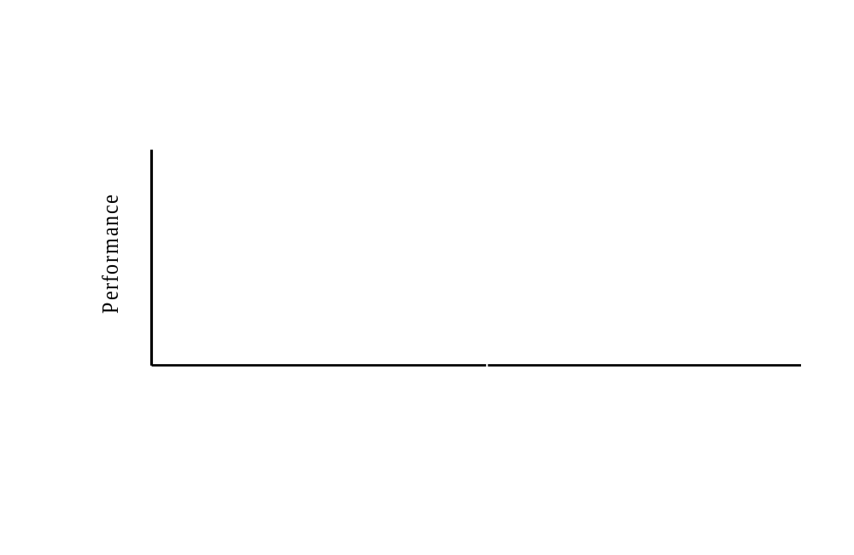
Professor Michael Porter of the Harvard Business School offers a useful way to think about choices about “who” and “what” in an integrated fashion.

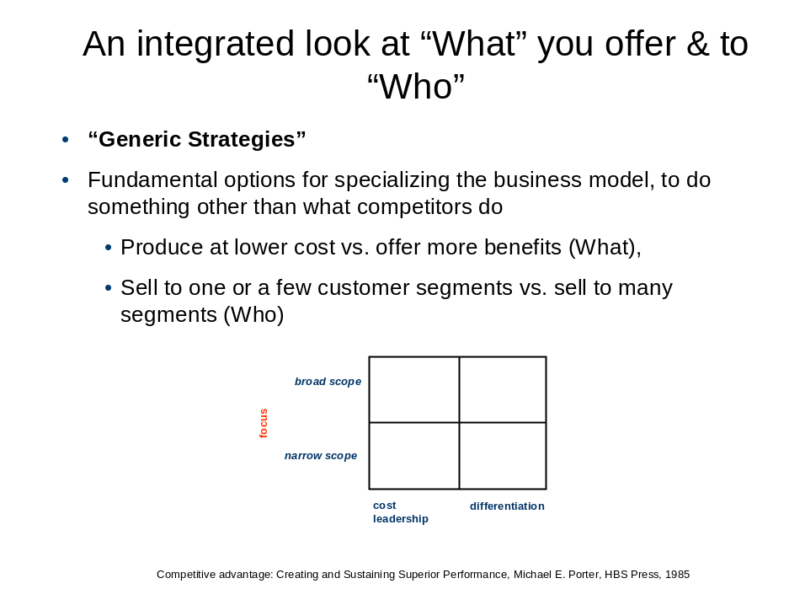

This picture, also known as the “generic strategies framework” – highlights that your choices of business model in terms of the Who and What cluster into four categories, narrow scope cost leadership, broad scope cost leadership, narrow scope differentiation and broad scope differentiation. The scope choice is obvious – are you aiming at a narrow segment of the market or at the broad market? Cost leadership means that you will attempt to offer the lowest cost version of the offering- differentiation implies that you aim to add more features (most likely at higher cost).

Example: DimSum@URdesktop

The DimSum restaurant has a broad scope cost leadership position relative to your friend’s which is narrow scope differentiation. Remember generic strategies are always assessed implicitly relative to something (e.g. industry average player)

Note that in principle, you could create as much value from either a differentiation or a cost leadership strategy. This is illustrated in the next figure. B is the willingness to pay of your customer, and C is the cost it takes to manufacture the product/service. Relative to the industry average player, you could pursue a differentiation strategy with higher B and C, or a cost leadership strategy with lower C and B. But what matters is B-C (= Value created).

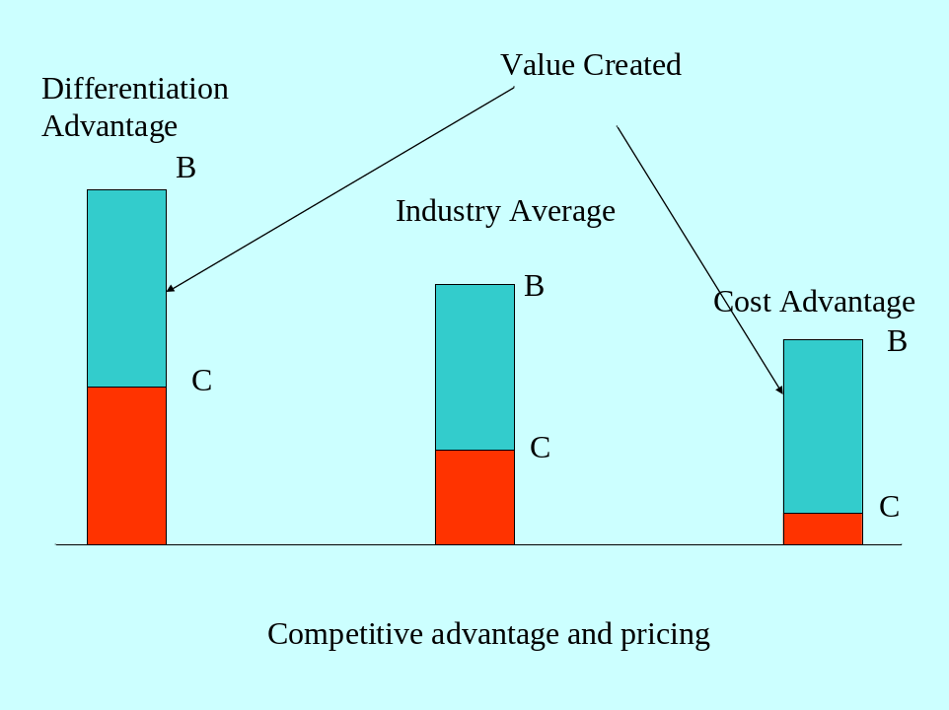

It is also worth noting that differentiation does not automatically mean premium pricing. Where you set price (P) between B and C depend on what economists call the “elasticity of demand” – how sensitive demand is to price. (eg. high elasticity = sharp drop in demand for increase in price). Thus if demand is highly elastic, and you chose a differentiation strategy, you might still price near the industry average and gain market share. In contrast, with elastic demand you would cut price relative to industry average if you had a cost advantage.

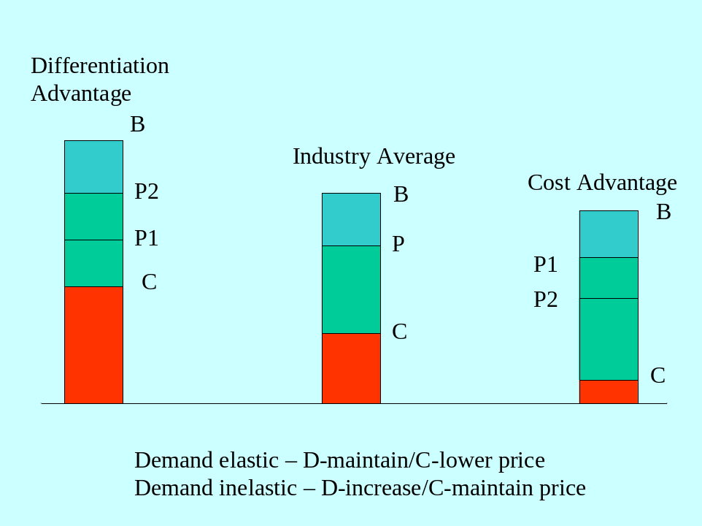

- How: Defining activities

Given your decisions of Who and What, How will you get your offerings to your customers? Answering this requires an enumeration of the activities you need to conduct to make your product / service offering and get it into the hands of your customers. A very useful representation of the set of activities that you should consider is also due to Professor Porter, and is referred to as a “value chain”.

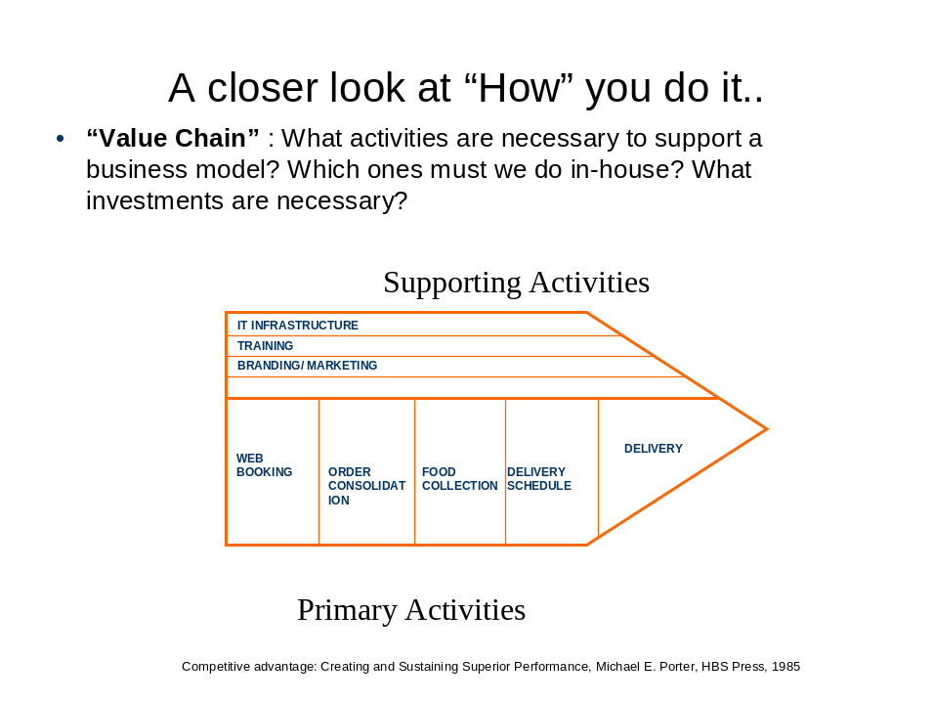

The generic value chain shown above could apply to any business. It simply says there are some primary activities (such as operations (e.g. manufacturing), distribution, and service) and secondary support activities (company infrastructure, HRM, R&D) that every business model must have.

Your task is to develop your own value chain for your business model. Make sure you answer the following questions:
- Given your choice of customers and products, what activities (primary and supporting) will you need to engage in?
Activity 1:

Activity 2:

Activity 3:

Activity 4:

Activity 5:
Activity 6:

Activity 7:

Example: DimSum@UR Desktop

Activity 1: Web booking
Activity 2: Order consolidation
Activity 3: Food collection
Activity 4: Schedule delivery
Activity 5: Delivery

- Which of these will you do yourself vs. outsource?
(Depending on how much detail you want to go into on this decision, you might also want to consult the workbook module on Outsourcing (Module Name: OUTSOURCE)

Activity 1: [self / outsource]

Activity 2: [self / outsource]

Activity 3: [self / outsource]

Activity 4: [self / outsource]

Activity 5: [self / outsource]

Activity 6: [self / outsource]

Example: DimSum@URdesktop:

Activity 1: Web booking - Self
Activity 2: Order consolidation - Self
Activity 3: Food collection – Self
Activity 4: Schedule delivery - Self
Activity 5: Delivery – Self

- What investments will you need to make in each activity? How quickly can you make them?

DimSum@URdesktop:
Activity 1: Web booking - Setting up a website with ordering and payment functionality. This can be done within a couple of days and requires a minimal four digit investment.
Activity 2: Order consolidation – Once the website is in place this requires no further investments.
Activity 3: Food collection – Hire delivery people
Activity 4: Schedule delivery – Once the website and software is in place this requires no further investments.
Activity 5: Delivery – The logistics system is fairly straightforward given that the food is collected from a single restaurant and delivered to businesses located in the same area. About three temporary workers are needed, who can be recruited within days, and a few bikes need to be purchased/rented.

Remember, If you are a diversifying entrant, at this point in the analysis, you might want to stop and consult Modules on Synergy Analysis (Module name: SYN) and Entry Strategies (ENTSTRAT)

As before, feel free to iterate your choices in terms of the Who, What and How as many times as you think it is useful to do so. Remember, before you move on to the next step, note that a good business model must at least meet the following criteria:
- Choices clear in what they include as well as exclude. This is why we force you to be brief in your description of you choices of Who, What and How!
- Internally consistent – are logically compatible, reinforce each other. For instance, if you are chasing quality conscious customers who value extra features, than obviously what you are offering is a differentiated product, and this should be obvious in your value curves; further your value chain should look appropriate for a differentiated product, with the need for investment in possibly R&D, marketing and manufacturing that are higher than typical.
- Externally consistent – make realistic assumptions about demand and your ability and costs to produce. In other words, you should have some confidence in your beliefs about the willingness to pay (B) and costs (C) as they apply to your offering, relative to the industry average.

End of Step 1, Module SEBO
Step Two: Estimating the impact of competition on your business model

It is often claimed by strategy professors that even if their students forget everything else they taught them, years after their MBA they are still likely to remember the “Five forces framework”. This is another very useful representation of competition that strategic analysis owes to Professor Michael Porter. His big insight was that it is not just those who sell what you do (rivals) who are competitors, but those who sell something very similar to what you sell (substitutes), those who can begin selling what you sell (entrants), those whom you purchase from (suppliers), and those who you sell to (buyers). All of these are competing with you to take away your profits! Why? Profits = (Price – Average Costs) x Volumes. Anybody who has “power”, i.e. the capability to lower price or volumes and raise cost is your competitor!

Applying Five forces analysis

- DEFINE THE COMPETITIVE SPACE

Begin by defining who your “rivals” are. These are players with very similar if not identical business models to yours. Then proceed to identify the other key actors that you will deal with – people you buy inputs from and sell outputs to (suppliers and buyers), and other firms that are competing with you (potential entrants and firms making products that can substitute for your products). Note that players can have many roles. It also pays to explicitly adopt two different perspectives: as a potential entrant, and as well as an incumbent (which you soon hope to be).
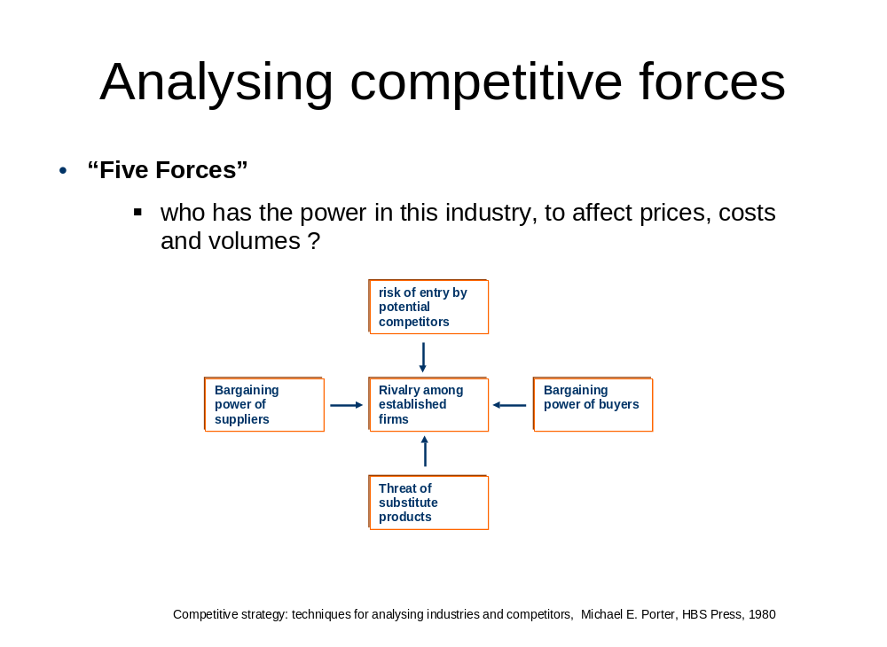
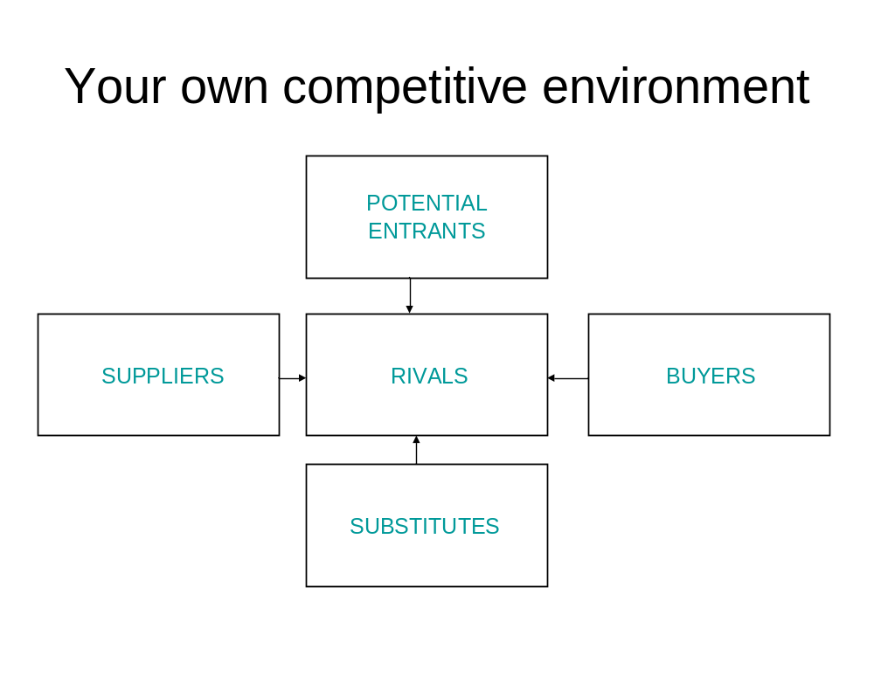
Fill in details for your own business opportunity

2) ASSESS THE POWER OF THE FORCES

For each of the five forces, assess the impact of this force on your business model by assessing the multiple factors for each force on a 1-7 scale. To give you a sense of what “Low” and “High mean, we have given you examples at each end of the scale, to help here your own business opportunity might lie. We also show you what scores our DimSum@URDesktop example might get. NOTICE: Take a close look at what is a low score and a high scores- some scales are reversed (highlighted)!!

The power of rivals

- Industry concentration. An industry is concentrated if just a few players have the majority of the market share. An industry is not concentrated if it has many players none of whom has a large market share. The degree of industry concentration is:
1 very low | Agriculture – Many small players compete with each other.
7 very high | Civil long range airplanes – Two players, Boeing and Airbus, dominate the entire market.

DimSum@URdesktop: The market has no other players like your friend; therefore as of now there is no rivalry. [ 1]

- Industry growth. The growth of the industry in terms of revenues is:
1 very high | IT outsourcing – In recent years this industry experienced double digit growth in global revenues.
7 very low | Physical mail (post) – In most economies the post market is declining.

DimSum@URdesktop: No information is given, but a guess is that it will not be high (5).

- Exit barriers. A firm may find it difficult or costly to exit the industry, or to reduce capacity. In this industry, exit barriers are:
1 very low | Plumber business – Few long term commitments, little or no stock, and no physical assets.
7 very high | Telecom industry – Telecom requires huge investments in assets that are difficult to redeploy for other purposes. The best alternative may be to stay in the business as long as revenues cover variable costs (but perhaps not fixed costs).

DimSum@URdesktop: The exit barriers are low. For your friend, this would mean firing the temporary staff and closing down the website (2).

- Product differentiation. This is the extent to which products are different from each other. In this industry, product differentiation is:

1 very high | Perfumes
7 very low | Most raw materials, like iron ore, coal, gold.

DimSum@URdesktop: Convenient order and delivery is what differentiates your friends product- as of now none matches this. (2).

- Economies of scale. Economies of scale are large when fixed costs are high relative to variable costs. In this industry, economies of scale are:
1 very low | Financial auditing services. People are the main cost component. For each additional audit, a financial auditing firm has to employ roughly the same number of people. As such the costs per audit hardly drop as production goes up.
7 very high | Software industry. Once the software has been developed, the cost of producing an additional unit is very low. For example, Microsoft spends billions on developing a new operating system. Once it has been developed, the cost of producing an additional copy of the software is close to zero (e.g. the cost of a CD or even less if the software is distributed online).

DimSum@URdesktop: In your friend’s model, the variable costs of collection and delivery (and associated hiring, training etc.) are the main drivers of cost on an ongoing basis. The fixed cost of the website will likely play a small role. (2).

Your total score on these five items: (

If your total score is above 17 (out of a possible 35), you should be warned that the forces of rivalry may have a strong downward impact on your prices and volume.

[For slide supplier power, see slide buyer power]
SUPPLIER POWER
- Supplier concentration. This is degree to which the suppliers’ industry is more or less concentrated than the focal industry. An industry is concentrated if just a few players have the majority of the market share. An industry is not concentrated if it has many players none of whom has a large market share. Suppliers to this industry are:
1 much less concentrated than focal industry | Book publishing – While the number of publishers with national or global coverage are limited, the main input for books – manuscripts from authors – are available by the thousands.
7 much more concentrated than focal industry | Airline industry – Many airlines compete with the biggest airline having less than 10% market share. Their most important suppliers are airplane manufacturers. Only two major players exist in that market, Boeing and Airbus.

DimSum@URdesktop: Three potential suppliers exist, yet DimSum@URdesktop would be the first with this business model (2).

- Industry’s share of suppliers’ outputs. This indicates how much of the suppliers’ industry is sold to the focal industry. Industry’s share of suppliers’ outputs is:
1 very low | Many basic materials, like steel and lumber.
7 very high | Railway operators – They take most, if not a all, output from the suppliers of railway carriages.

DimSum@URdesktop: While DimSum@URdesktop would perhaps be one the most important customers, most other customers are from outside the focal industry (2).

- Switching costs when changing suppliers. These are the fixed costs that buyers in your industry incur when they switch suppliers. In this industry, switching costs when changing suppliers are:
1 very low | Clothing retailing. Customers can walk out of one clothing store and go directly to another without any setup costs.
7 very high | Business software (like enterprise resource planning). Once it has been implemented, many processes have been adjusted to the software, and employees have been trained to use it, it is very costly to switch to an alternative supplier.

DimSum@URdesktop: The level of integration with the supplier is low. The menu may be somewhat specific to the supplier, and may need adjustments when changing suppliers (3).

- Supplier product differentiation. This is the extent to which suppliers’ products are different from each other. Supplier product differentiation is:
1 very low | Most raw materials, like iron ore, coal, gold.
7 very high | Perfumes.

DimSum@URdesktop: The supplier is the best of the three restaurants, suggesting that there is some product differentiation (4).

- Costs of purchase as percentage of total costs. The extent to which the industry’s costs are determined by the costs of purchase (from a given supplier industry) is:
1 very low | Software – The biggest cost of production is paying employees.
7 very high | Food retailing / supermarket. Costs of purchase make up the majority of the costs of goods sold.

DimSum@URdesktop: The costs of purchase is 86% (= 90 / 105) of revenues, i.e. very high (7).

- Supplier substitutes. This is the extent to which alternative products are available that offer similar functionality as the suppliers’ products. The availability of substitutes for suppliers’ product:
1 very low | Electricity.
7 very high | Transportation – plane, train, bus, car, ferry, and by foot.

DimSum@URdesktop: There is no reason why the delivery service should be limited to dim-sum and not be extended to other types of food (6).

- Threat of forward integration. This is the extent to which suppliers can credibly threaten to enter the focal industry. The threat of forward integration is:
1 very low
7 very high

DimSum@URdesktop: If your friend can easily enter into the business, so can the main supplier (7).

Overall, is there high bargaining power of the suppliers for the focal industry?
Yes No

Which conditions significantly affect the bargaining power of suppliers?

As a potential entrant, do you consider the bargaining power of the suppliers favorable or unfavorable? Why?

If the power of suppliers is high, what activities (e.g., new innovations, capital investments, switching costs) could a potential entrant undertake to reduce their power?
- Work with multiple restaurants
- Build a cost advantage in ordering and logistics to reduce threat of forward integration.
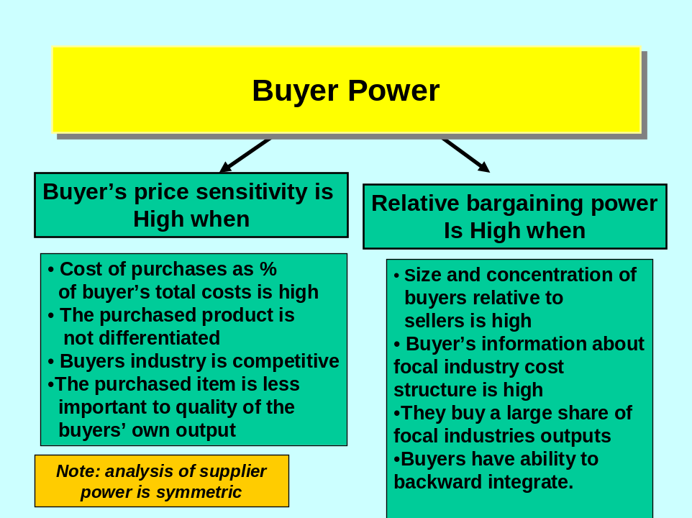

ONCE SUPPLIER POWER IS OKAYED, I CAN REPLICATE 1:1 HERE.

- Buyer concentration.
DimSum@URdesktop: Many potential buyers, and just one (or few) suppliers (1).

- Buyer’s share of industry’s outputs.
DimSum@URdesktop: All deliveries will go to office workers (7).

- Switching costs when changing suppliers.
DimSum@URdesktop: Customers can easily change restuarants (1).

- Industry’s product differentiation.
The supplier is the best of the three restaurants, suggesting that there is some product differentiation (4).

- Costs of purchase as percentage of total costs.
DimSum@URdesktop: Lunches are a small part of the consumer’s overall budget (2).

- Buyer substitutes.
DimSum@URdesktop: Customers have several alternatives, e.g. different food types (including bringing on lunch) (7).

- Threat of backward integration.
DimSum@URdesktop: Low (7).

Overall, is there high bargaining power by the buyers for the focal industry?
Yes No

Which conditions significantly affect the bargaining power of the buyers?

As a potential entrant, do you consider the bargaining power of the buyers favorable or unfavorable? Why?
Favorable.

If the power of buyers is high, what activities could a potential entrant undertake to reduce their power?
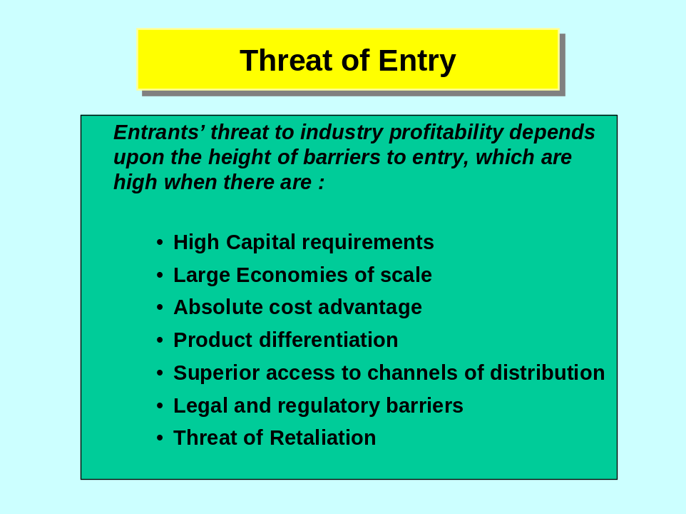

- Economies of scale. This is the extent to which a firm’s average unit costs go down as the firm’s total production increases. Economies of scale are large when fixed costs are high relative to variable costs. In this industry, economies of scale are:
1 very low | Financial auditing services. People are the main cost component. For each additional audit, a financial auditing firm has to employ roughly the same number of people. As such the costs per audit hardly drop as production goes up.
7 very high | Software industry. Once the software has been developed, the cost of producing an additional unit is very low. For example, Microsoft spends billions on developing a new operating system. Once it has been developed, the cost of producing an additional copy of the software is close to zero (e.g. the cost of a CD or even less if the software is distributed online).
DimSum@URdesktop: Some possibly present in ordering and logistics (4).

- Network effects. This is the extent to which a customer’s willingness to pay for a firm’s product goes up if other customers buy this product from the same company. In this industry, network effects are:
1 very low | Office supplies. The customer’s value of office supplies from a specific company do not depend on how many other customers buy office supplies from that company.
7 very high | Social networking websites. An online place for networking (e.g. Linkedin) or for keeping in touch with friends (e.g. Facebook) becomes more valuable the more people belong to the network.
DimSum@URdesktop: Low (1).

- Customer switching costs. These are the fixed costs that customers incur when they switch suppliers. In this industry, customer switching costs are:
1 very low
7 very high
SEE SUPPLIER POWER

- Capital requirements. These are the financial resources to setup the business and enter the industry. In this industry, capital requirements are:
1 very low | Consultancy industry. No significant financial investments are needed to setup a consultancy firm.
7 very high | Chip industry. Setting up a production facility requires an investment in the order of magnitude of a billion US dollars.
DimSum@URdesktop: Initial investments are just £ 1000 (1).

- Absolute cost disadvantage. Independent of their size (or production volume), incumbents could have a cost advantage that is difficult for new entrants to bridge. For example, incumbents may have strong brand recognition or efficient production methods developed through years of experience. On the other hand, it could be that new entrants have the advantage. In this industry, independent of size a new entrant has:
1 high cost advantage
7 high cost disadvantage | Sportswear – Companies in this industry spend millions building their brand through advertisements and endorsements of athletes.
DimSum@URdesktop: No cost advantage (4).

- Proprietary technology / knowledge. This is the extent to which the technology and knowledge necessary to produce in the industry are protected by secrecy, patent, or copyright. In this industry, the extent to which technology / knowledge are proprietary is:
1 very low | Haircut. No patented knowledge and proprietary knowledge need to be acquired for cutting someone’s hair.
7 very high | Drug industry. Most new drugs are protected by patents, granting the exclusive rights to a single party.
DimSum@URdesktop: No proprietary technology or knowledge (1).

- Difficulty of accessing distribution channels. In this industry, the difficulty of accessing distribution channels for a new entrant are:
1 very low | Many products and service that are sold online, e.g. online education.
7 very high | Food retailing. A new item must obtain shelf space, which is often only possible by replacing another item.
DimSum@URdesktop: Low (1).

- Government policy. A government can hinder or stimulate the entry of new participants to an industry. For example, it may offer subsidize to start ups or limit entry through regulation. In this industry, government policy:
1 stimulates new entry | Green energy. Many governments around the world provide substantial tax incentives or direct subsidies for research into and exploration of green energy.
7 severely limits new entry | Nuclear energy. Governments decide which parties may produce nuclear energy, if at all possible.
DimSum@URdesktop: No particular government policy either stimulating or hindering entry (4).

- Expected retaliation. This is the extent to which incumbents are expected to retaliate to defend their market share when a new party enters the market. Retaliation includes lowering prices and increasing advertisement. In this industry, expected retaliation is:
1 very low
7 very high
DimSum@URdesktop: If the business model is a success, then at least one of the restaurants may enter (4).

Overall, is there a high threat of new entrants into the industry?
Yes No

YES

All conditions are not equal, which conditions significantly affect the threat of new entrants?

As a potential entrant, do you consider the threat of new entrants favorable or unfavorable? Why?

What specific obstacles will your company have to overcome to enter this industry?

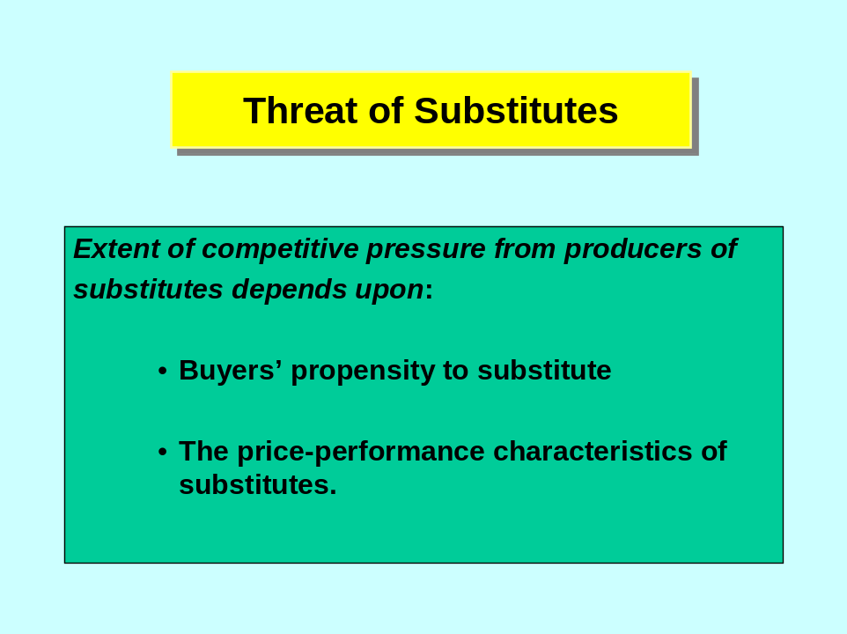

- Performance – price ratio of substitutes. Substitutes become more attractive if they offer more value for less money. The performance – price ratio of substitutes is:
1 very low | Printed newspapers vs. online news sites – News appears faster online and is often free.
7 very high | Online news sites vs. printed newspapers – News appears faster online and is often free.
DimSum@URdesktop: Two substitutes: eating in the office cafeteria, bringing one’s own lunch, or different delivery are very comparable on performance / price (4).

- Buyer’s switching costs to the substitutes. These are the fixed costs that buyers in your industry incur when they switch to substitutes. In this industry, switching costs when changing to substitutes are:
1 very low | Switching between online news sites and printed newspapers. (Even if you switch from printed newspapers to online sites and you have a subscription, the costs of the subscription are sunk).
7 very high
DimSum@URdesktop: Switching costs to substitutes (eating in the office cafeteria, bringing one’s own lunch, or different delivery (1).

Overall, is there a high threat of substitute products for the focal industry?
Yes No

Which conditions significantly affect the threat of substitute?

As a potential entrant, do you consider the threat of substitute products favorable or unfavorable? Why?

If the threat of substitute products is high, what activities could a potential entrant undertake to reduce the threat’s likelihood?

OVERALL EVALUATION

Which of the above 5 forces most significantly impact the overall structure of the industry?
- Bargaining power of suppliers.
- Risk of potential entrants.
- Rivalry

Is this an attractive industry for a company to do business in? Yes No Why?
No. Even if value can be created through this business, it will be hard to capture it (too much dependence on one supplier and high risk of entrants).

THE WHY SHOULD FOLLOW FROM THE ANALYSIS, OR EVEN BE COMPUTER GENERATED.

What strengths will a company need to have to succeed in this industry? What weaknesses will they have to avoid?
The business should excel in:
- Matching demand to supply, i.e. getting customer orders to restaurants.
- Efficient logistics network.

Based on this analysis, what strategy should a company select to succeed in this industry?
Following from the response above, the company should build strong capabilities in web interface and delivery logistics.

Finally, based on your analysis what changes do you anticipate in this industry? (i.e., What current structural trends will affect the five forces?) What can your company do to take advantage of these changes?

Step III: Conclusions from the analysis

At this point, the program should generate, in the form of a report,
- A clear definition of the business model
- A value curve comparing your own to competitors
- A value chain showing what activities you will need to engage in
- A five forces analysis showing which forces you will need to be most worried about
- And what you might do to protect yourself from them

Costas Markides, All the Right Moves: A Guide to Crafting Breakthrough Strategy (HBS Press, 1999)
Blue Ocean Strategy: How to Create Uncontested Market Space and Make Competition Irrelevant by W. Chan Kim and Renée Mauborgne, HBS Press, 2005
Competitive advantage: Creating and Sustaining Superior Performance, Michael E. Porter, HBS Press, 1985
Competitive advantage: Creating and Sustaining Superior Performance, Michael E. Porter, HBS Press, 1985
Competitive strategy: techniques for analysing industries and competitors , Michael E. Porter, HBS Press, 1980

